**Project on Income inequality before and after taxes**

**Summary**: To Analyze income inequality before and after taxes and how much do countries redistribute income?

**Source for excel**: https://ourworldindata.org/income-inequality-before-and-after-taxes

**Contents**:

1. Importing data from csv file to My SQL
2. Creating a new table for Total_Income for market and household income
3. Importing all tables from MY SQL to Power BI
4. Creating a dashboard in Power BI

Imported from below csv data to MySQL



Database:

Incometax_portfolio

Tables:

1. Gini_coefficient
2. Income_inequality
3. Reduction_income_inequality
4. Total_Income

Gini_Coefficient - is a statistical measure of economic inequality in a population.

Gini_coefficient table contains data of equalized market income and house hold income.

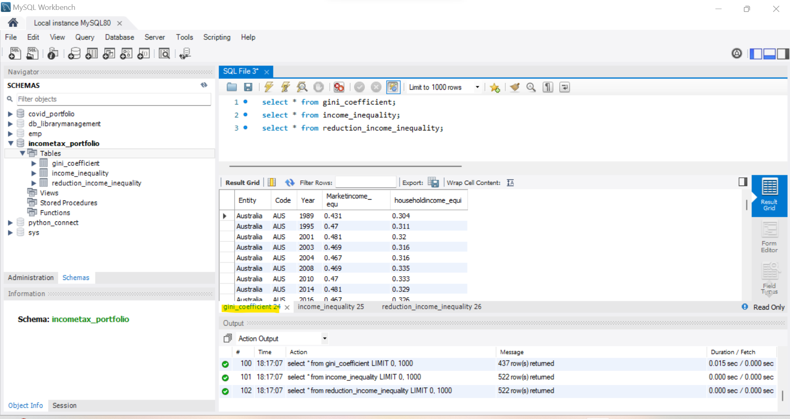

Income_inequality table contains data income remaining after deduction of tax(disposableincome),population in different country with respect to year.

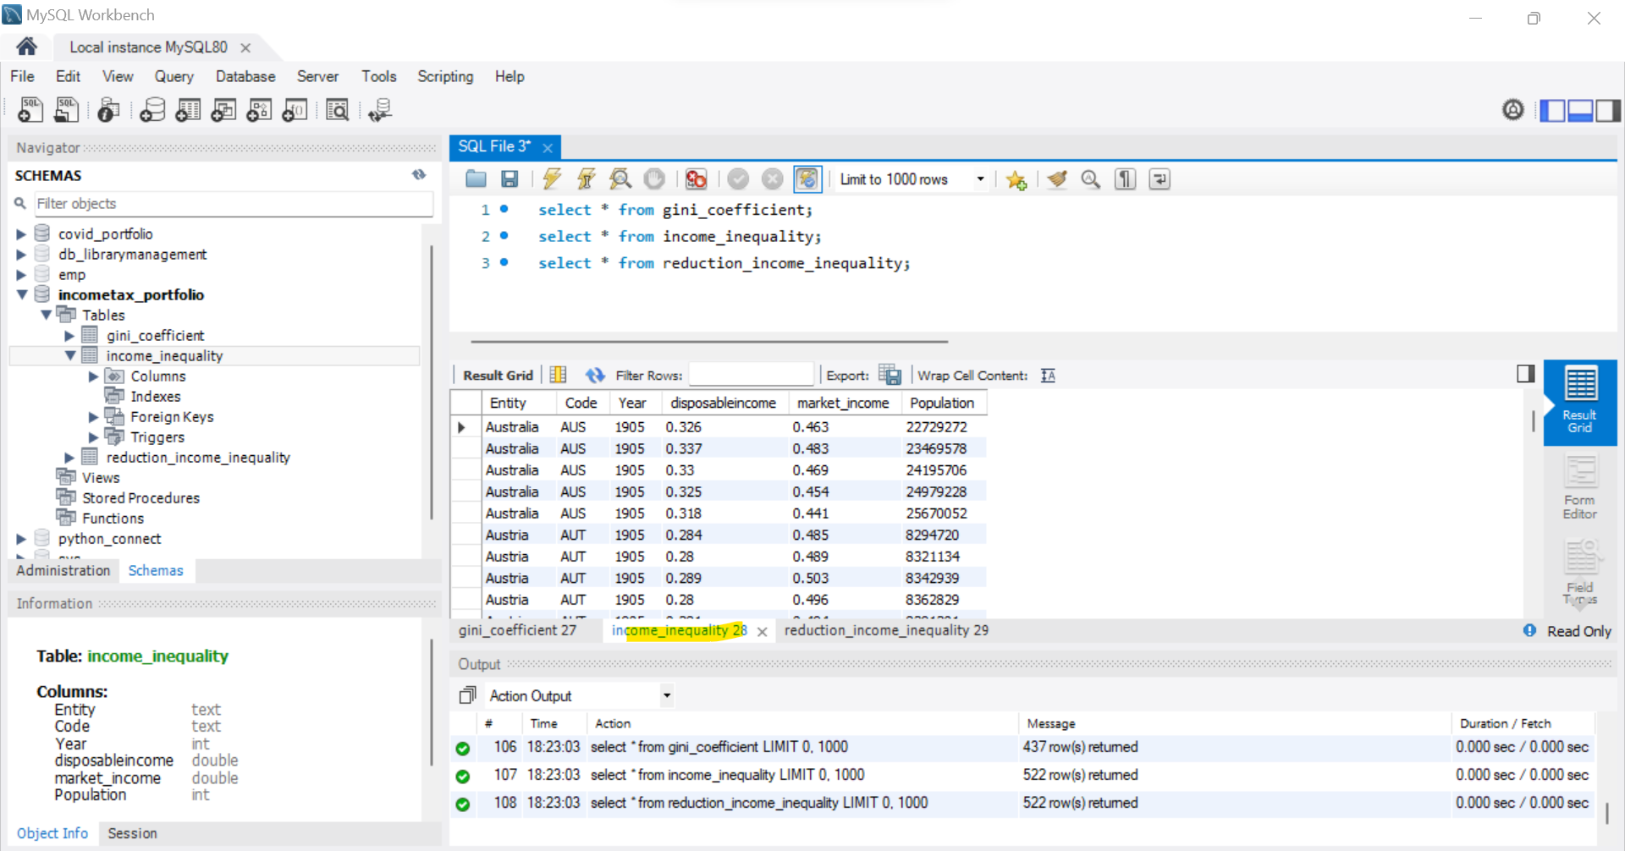

Reduction_income_inequality table contains percentage reduction in Gini coefficient before and after tax

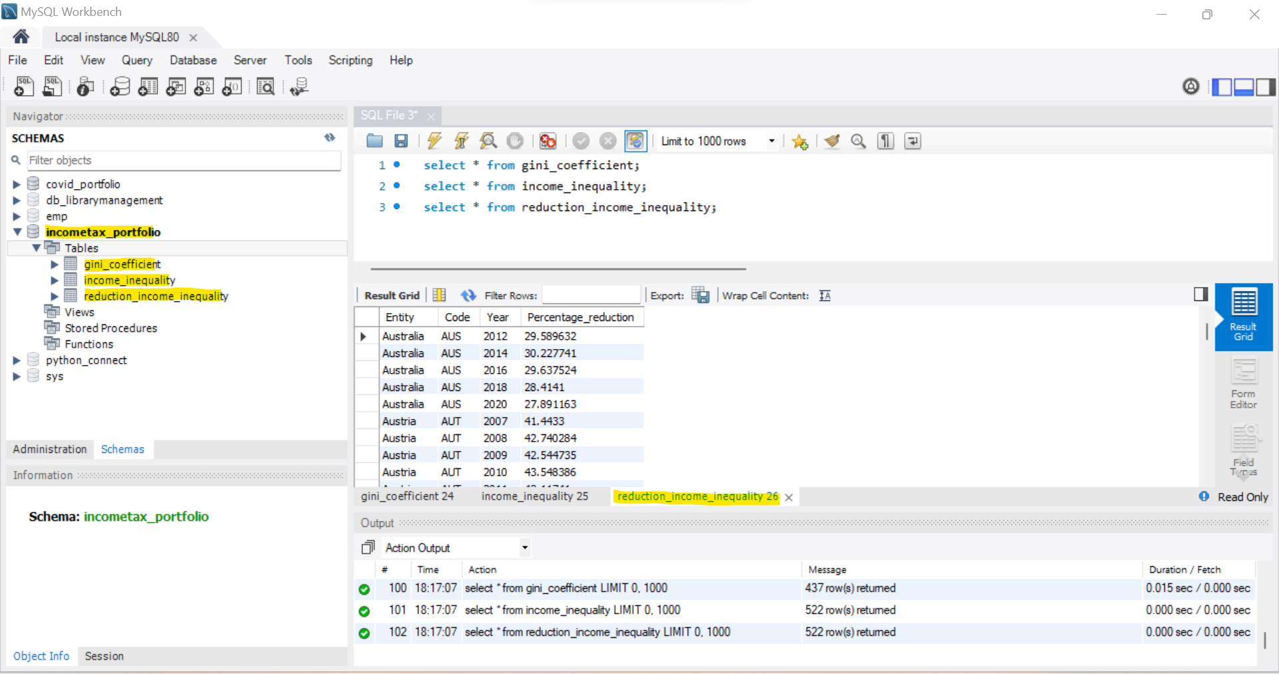

Created a new table Total_Income with Population from tables gini_coefficient, income_inequality in order to have total amount in household and market income

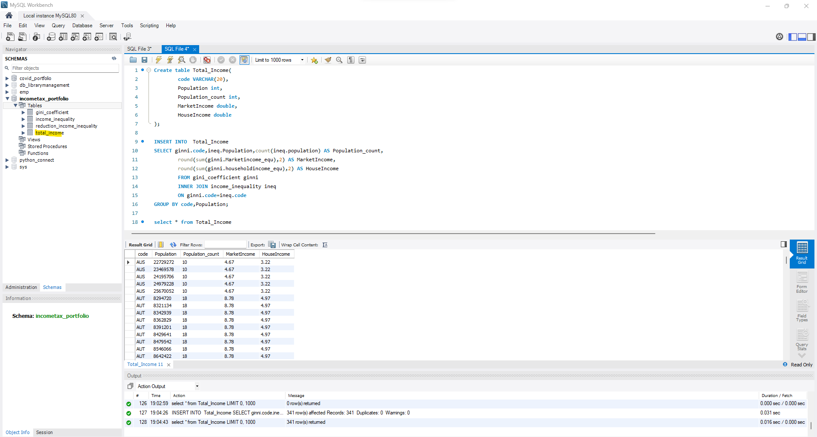

**POWER BI**

Now we have 4 tables to create dashboard in POWER BI

Importing tables from My SQL to Power BI. Transform and load data in power BI by making necessary changes in power query editor

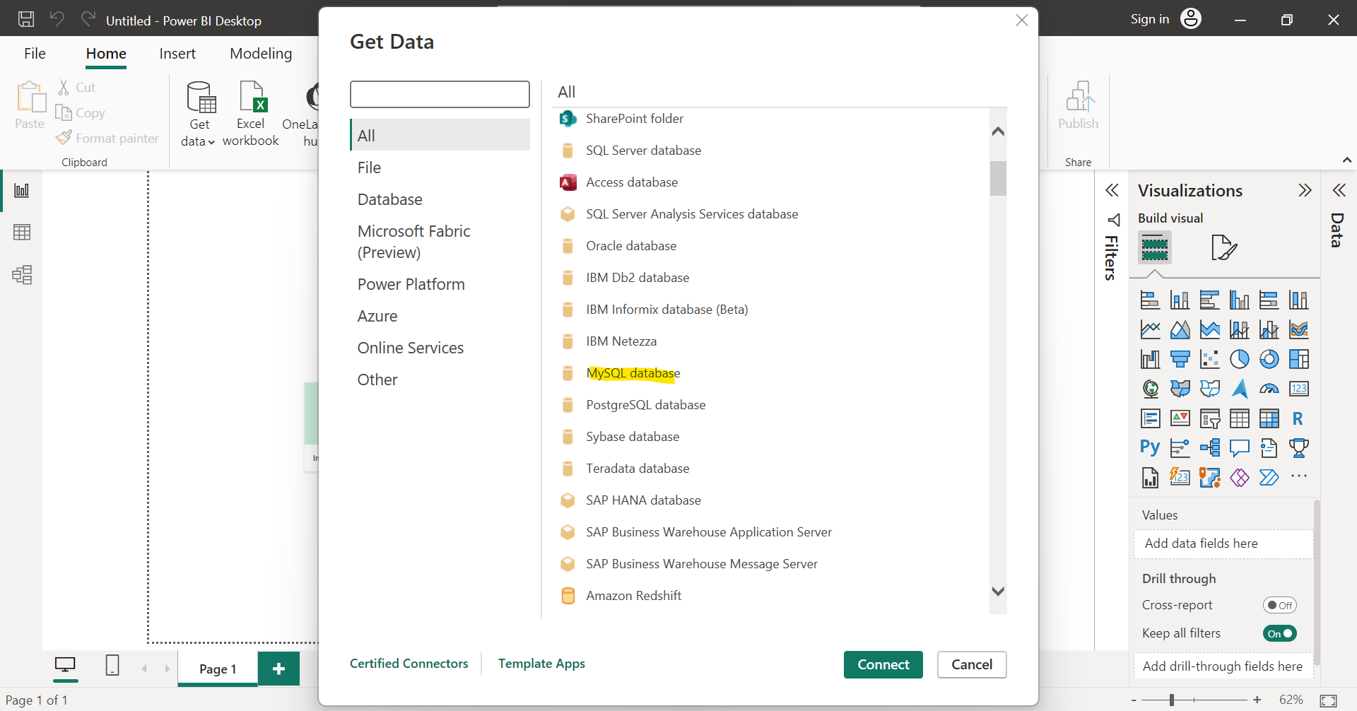

Tables imported in Power BI

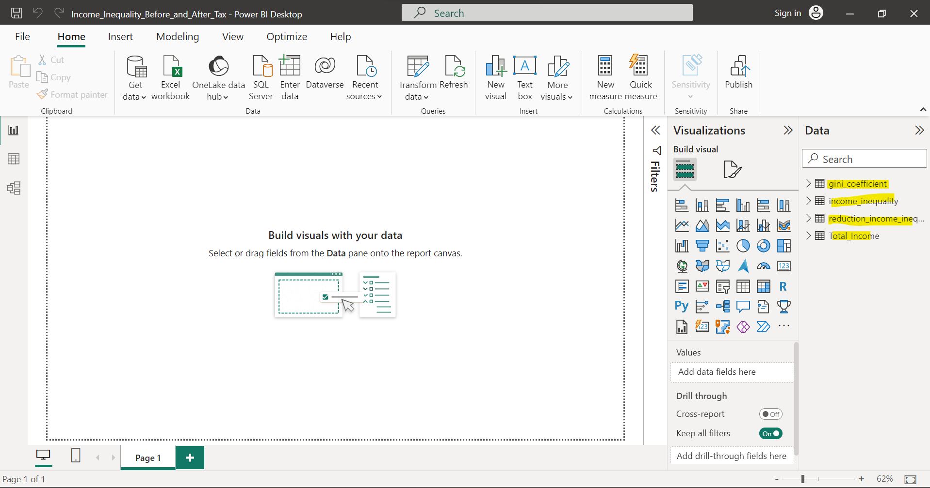

Interactive dashboard

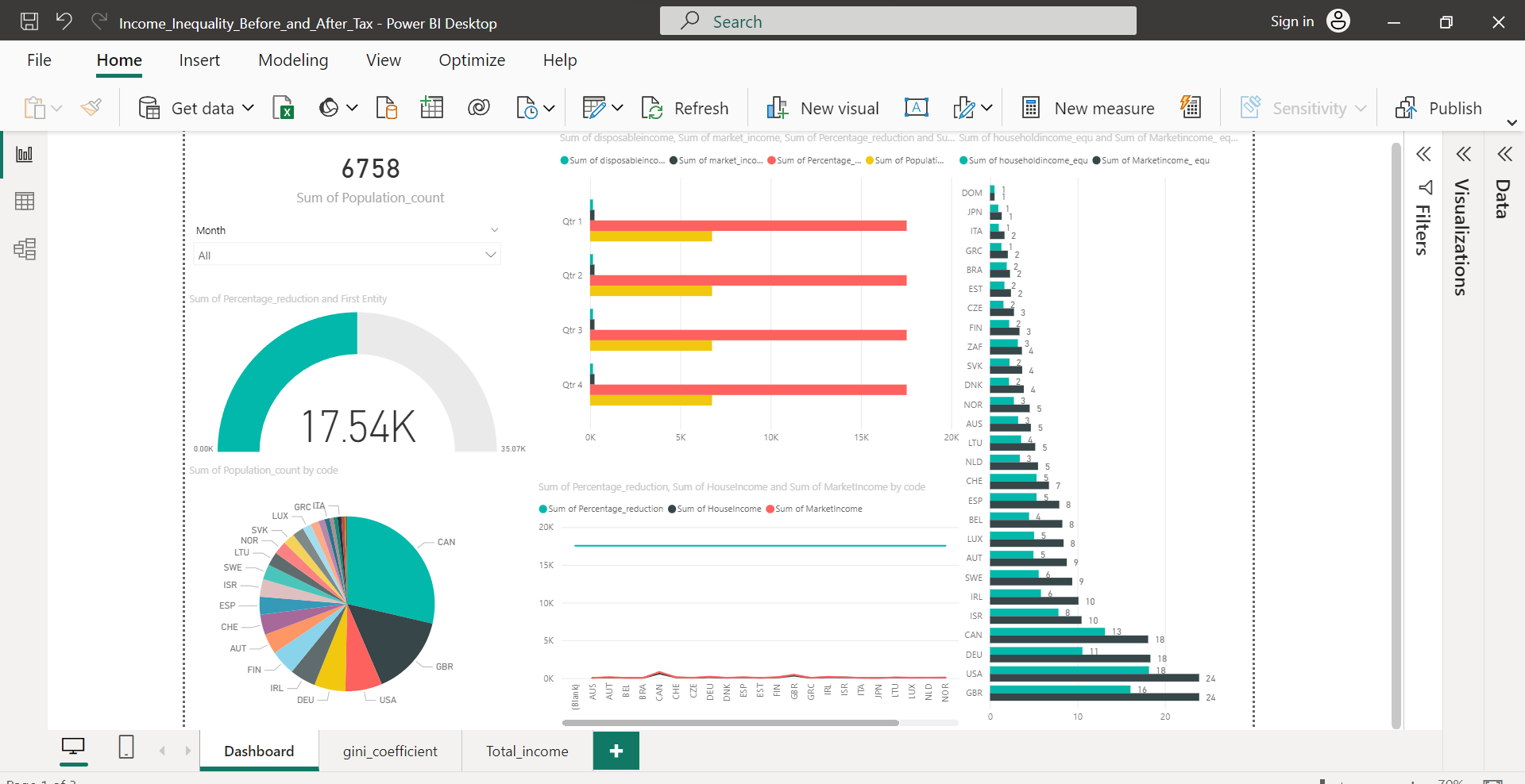

Gini coefficient analysis

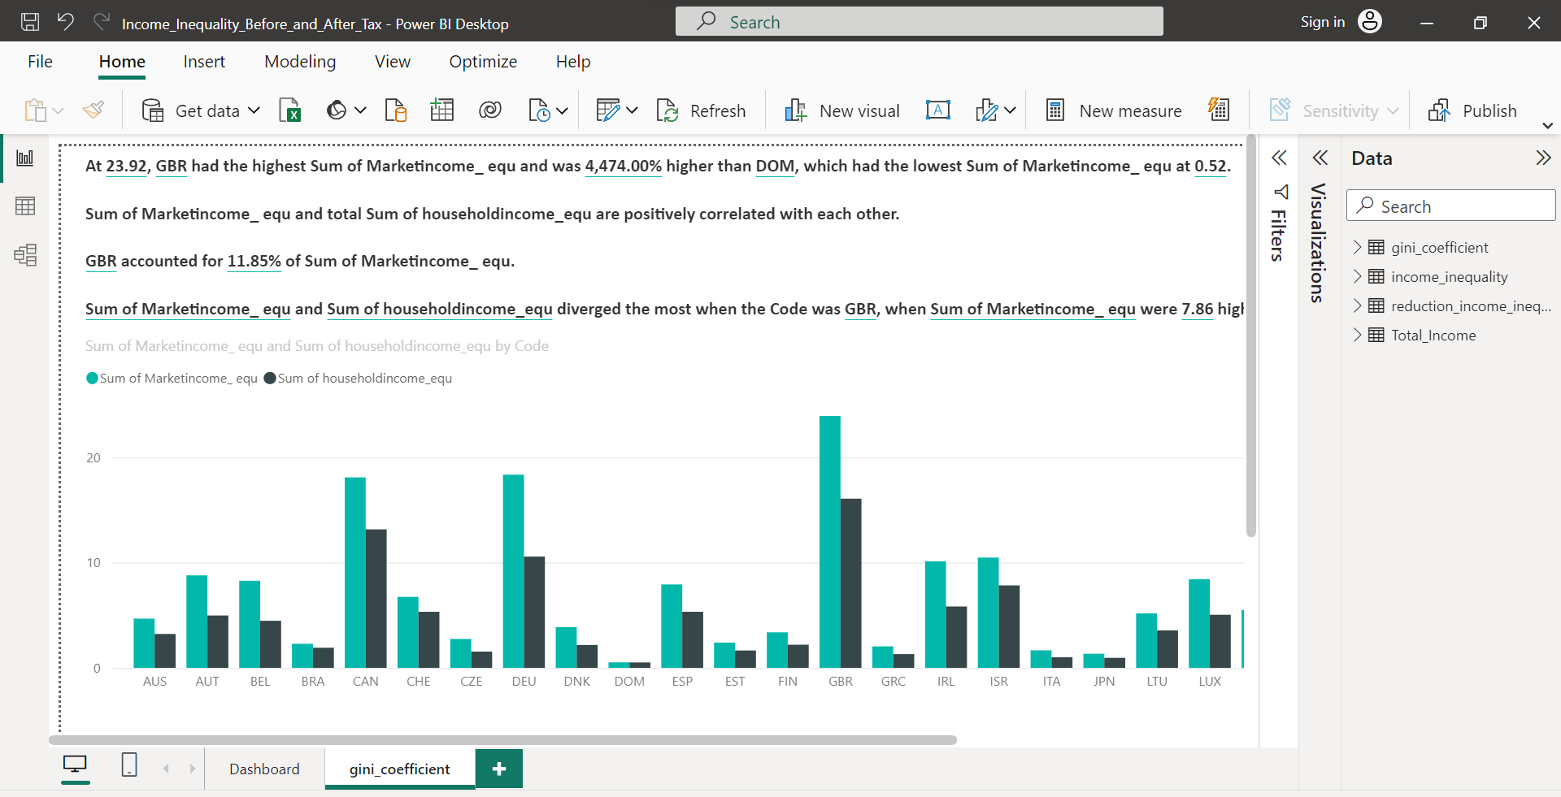

Total income analysis

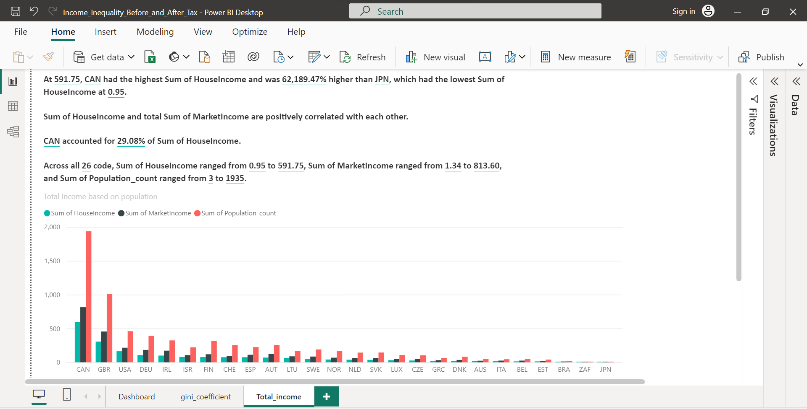

Power BI attachment

